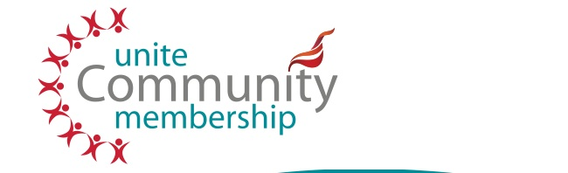
Report to Leeds Unite Community Branch
Unite Community North East (Yorkshire & Humberside)
Regional Workshop 2014

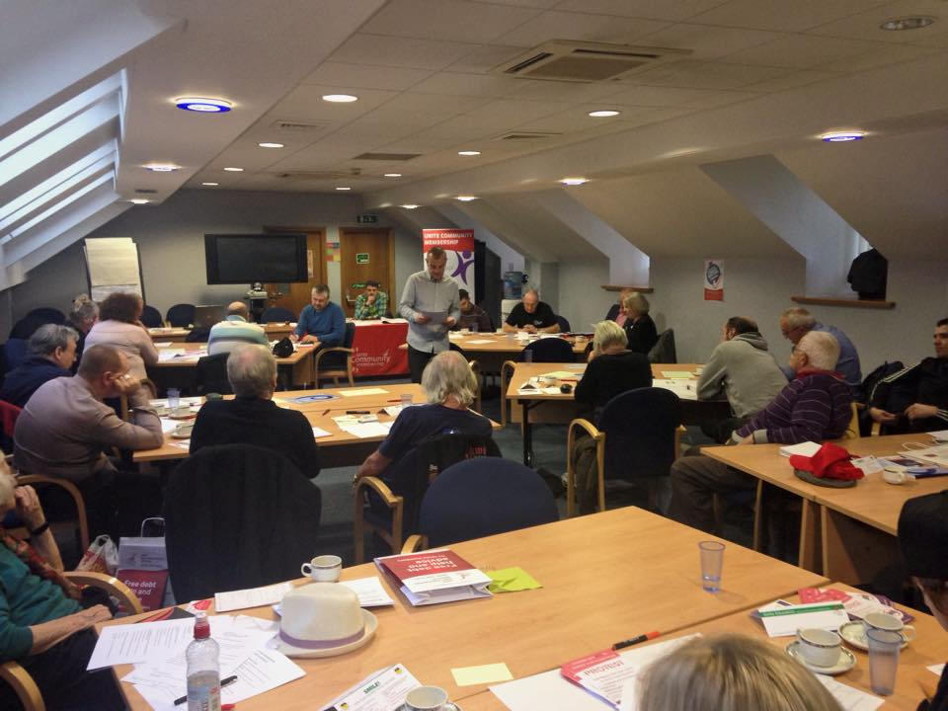
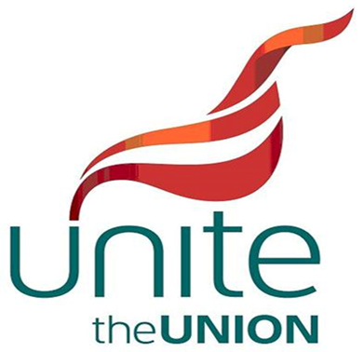
Introduction
Unite Community held a regional workshop on Thursday 13th November 2014 at the Unite offices in Leeds. There were up to four representatives from each of the following areas: Barnsley, Doncaster, Grimsby, Huddersfield, Leeds, Newcastle, Sheffield and Teesside. There were four representatives from Leeds: Patrick Hall, Gerry Lavery, Mark Mason, and Dave Robertson. Joe Rollin, the regional Unite Community Co-ordinator, hosted the day with the assistance of Claire Mawson from Unite.
Joe pointed out that five branches have now been established and others are in the process of being set up. Community centres have been opened in Durham and Barnsley, both in NUM premises. Two branch blogs are up and running, and there are now nine Unite Community Facebook pages. There are 1,000 Unite Community members in the North East region. The general message was that this has been significant and encouraging growth over a relatively short period of time.
One of the most instructive and interesting parts of the day was the opportunity to meet representatives from each area and to learn about what they have been involved in and have achieved. The more established branches have been particularly impressive in their progress and an inspiration to those of us at earlier stage of development.
We also heard from representatives of two important campaigns, the Barnsley Freedom Riders and the Orgreave Truth and Justice Campaign. The remainder of the day involved very helpful sessions on legal services, training and recruitment.
We look at each session in turn and then try to draw some lessons from the day.
Reports from the areas
Each branch or area presented the activities they have undertaken and the issues and lessons they have drawn from their work. In what follows in this section, we draw out examples of their work, by no means exhaustive, and the issues emerging.
A striking feature of the activity in more developed branches is the amount of work that is undertaken supporting members and others in difficult circumstances due, largely, to a decision by government to impose cuts directly attributable to the reckless behaviour of banks in the late noughties and a subsequent bail-out by the state and it’s tax payers. The ideologically-induced and opportunistic restructuring of social security, which has resulted in punitive policies and practices, represents a severe assault and humiliation on sections of this country’s citizenry, leaving many in dire need of help with the basic necessities of life. Below we list some of the responses in different areas of the region to such a situation.

Food, clothing and furniture
In Durham for instance, Unite Community has helped to set up as a socialist clothing bank in nearby Brandon, although this was attacked by a neighbouring Conservative MP as being ‘politically driven’, which, given the deeply ideological nature of the austerity measures, is a truly staggering statement. The Doncaster branch started with a food bank, and Grimsby Unite Community makes regular donations to local food banks. In Barnsley, Durham and Newcastle there also links to food banks.
Meals are also available in a church-run drop-in centre to which Barnsley’s Unite Community Branch has links. Barnsley also has access to recycled clothing (Dress for Less), furniture and computers for its centre’s users.
Welfare rights advice
Welfare rights advice has also been a key issue for many branches. In Barnsley, for example, there is a well-developed advice service where people are given not only good advice but are also represented at appeals tribunals. The Barnsley branch has had some notable successes in raising the level of some people’s incomes. The Durham branch is also involved in giving regular welfare rights advice.
Barnsley members pointed out that of those coming to their support centre for advice, ‘most’ end up joining Unite Community. In short, Barnsley’s approach, we were told, is: ‘solve, alleviate, and recruit.’
In Newcastle, work has included welfare rights advice, and assistance given to claimants going to appeals tribunals. And in Doncaster the branch has been involved in training for tribunals. Most branches have also been involved in leafleting, especially outside job centres on the question of sanctions and the bedroom tax.
It was also pointed out that members from the Leeds branch took part in welfare rights training provided through Unite by the Child Poverty Action Group.
Huddersfield informed us of 35 appeals connected to the bedroom tax which were taken to court for review because Kirklees Council had under-used their bedroom tax relief fund. Twenty nine of the appeals were successful, although, unfortunately, the DWP is appealing against these judgements.
While valuable support work is taking place in Unite Community branches, it was also pointed that this often takes place in a way which raises people’s consciousness politically, so the approach is not simply one of ‘service provision’, important though that unfortunately is at present. The importance of networking with other local organisations that can help was also regarded as crucial to the work of Unite Community.

Education and training
The Durham centre is making available recycled computers, equipped with the Linux computer system, on an open access basis. Similarly, in the Barnsley centre, basic introductory computer lessons are available.
Barnsley has also established English for speakers of other languages (ESOL) classes for those users wishing to learn English with the help of the British Red Cross.
Community members in Newcastle and Barnsley have also run courses in public speaking.
Barnsley has also recently set up a Unite radical library with a collection of donated books on trade unionism and politics.
Campaigning
As was pointed out at the workshop, it’s no use simply plugging the gaps left by state-imposed cuts, unless campaigning raises awareness at both at a local and national level. Thus, it became very evident during the course of the day that campaigning is a key feature of area and branch activity.
Range of campaigns
Most branches have been involved in one more of the campaigns listed below, although the list is not exhaustive.
- Abortion rights
- ATOS
- Barnsley Freedom Riders
- Bedroom tax
- Benefit sanctions
- Council tax
- Disability benefits cuts
- Durham Miners Gala
- Fast food rights
- Hands Off Our Homes
- Local and national strikes
- Nursery closures
- Orgreave/Miners Strike
- People’s Assembly anti-cuts march
- TUC march - Britain needs a pay rise march.
- Workfare

The Sheffield model
It is worth mentioning that Sheffield Unite Community Branch has particularly followed a campaigning approach. For instance, members have taken direct action against sanctions by occupying a DWP building, and, in relation to cuts to disability benefits, disabled members joined others in chaining themselves to railings at a protest in Westminster. They have also campaigned against nursery closures, which included a resort to court action, and they protested against a local charity involved in workfare. A Tesco lorry drivers’ strike was given good support by the Sheffield branch, which, members felt, gave the drivers greater confidence. Sheffield’s direct action approach has resulted in significant membership recruitment. They now have over 300 members.
Other campaigns
The Leeds Branch emphasised a range of campaigns, but particularly mentioned the work of Hands Off Our Homes and the overlapping membership between the latter and the Leeds Unite Community. Our support for the Barnsley Freedom Riders, Fast Food Rights and the Orgreave Truth and Justice Campaign, as well as involvement in national demonstrations, was also raised.
Doncaster Unite Community has been involved in a number of interesting campaigns, including the lobbying of Ed Miliband, the local MP. Members there have also organised protests against an active anti-abortion/pro-life group.
Representatives from Huddersfield mentioned that they had given support to two activists who, along with others, occupied Barclays Bank as a protest against the bedroom tax (ultimately introduced because of the recklessness of the banks more generally). This resulted in a court case in which one of the protesters was acquitted and the other given a year’s conditional discharge. Huddersfield also reported on campaigns against sanctions outside a local job centre and, to link with PCS staff within the DWP, came up with the inspired slogan, ‘No sanctions for claimants, no targets for staff’.
Members of Unite Community in Teesside are becoming increasingly active and now have 60 members. They have organised a protest against benefit cuts and sanctions in respect of people with disabilities and job seekers for 6th December 2014 outside Middlesbrough Town Hall. All other branches are welcome to go along and support this event. The protest begins at 12pm.
A member from Grimsby told us of his involvement in anti-UKIP campaigning, including standing as a candidate against them in a council election. The longstanding Labour MP for Grimsby, Austin Mitchell, is standing down at the next election and the constituency is regarded as a possible winnable seat for UKIP.
For campaigning and support purposes, links between Unite Community branches and trades councils was also emphasised by some delegates, although there was also recognition that some trades councils needed reinvigorating.
The impression left by the workshop was that branches were very committed to campaigning, not only for their own members but for the wider labour movement and other campaigns as well. The ‘Sheffield model’ stood out as shining example for the effectiveness of campaigning and recruitment.
Barnsley freedom Riders and the Orgreave Truth and Justice Campaign
There were also brief presentations on these two important on-going campaigns. These were both inspiring talks, and members are asked to continue to lend their support to both campaigns.
Barnsley Freedom Riders
Jennifer Bush, a representative from both the Freedom Riders and Sheffield Unite Community, reported on this campaign. It began with the recent withdrawal of the usual free travel for senior citizens and for people with disabilities in South Yorkshire. This has involved regular direct action of a non-violent kind, especially boarding trains and withholding fares as a protest. While free travel was restored for those with disabilities, this is not the case for senior citizens, so the campaign continues.
On 23rd June this year a protest was held at Sheffield Railway Station when a heavy police presence resulted in the arrest - with the use of force - by British Transport Police of Tony Nuttall and George Arthur. The incident was filmed by Jennifer on her mobile phone and obviously provides an important source of evidence. Tony and George have been charged with obstructing the police and not having valid rail tickets. They are due to appear at Sheffield Magistrates Court on Monday 8th December when five days have been set aside for their trial. A protest will be held outside the court from 9 a.m. on this day and Unite Community members are invited to go along to show their solidarity.
Orgreave Truth and Justice Campaign
Barabara Jackson from The Orgreave Truth and Justice Campaign updated us on the campaign. It dates from the 1984 Miners’ Strike when a confrontation took between the miners and police. Miners were subjected to unusually violent policing and at the subsequent trial of arrested miners it was clear that as the trials collapsed the police had colluded over their statements rather than compiled them independently as required. In wake of Hillsborough, the South Yorkshire Police referred themselves to Independent Police Complaints Commission who promised to undertake a scoping exercise to see if there were grounds for an inquiry. This has now lasted two years and a protest was due to take place outside the IPCC headquarters in London on Friday 14th November to demand progress on the unacceptable delay by the IPCC. A delegation from the campaign was also due to meet the representatives of the IPCC on the same day.
The campaign has also been encouraged by the fact that a motion in Parliament, put down by a Labour MP, that the Thatcher government had misled the public over pit closures during the strike, was not opposed by the current government.
Unite Community members are encouraged to do what they can to support the campaign, perhaps by raising it publicly and writing to their MPs.
Legal services, training and recruitment
In the afternoon there were presentations from Thompsons, the trade union solicitors, and Robbie Faulds, a Unite education officer, who talked about courses to support Unite Community members. The final session was on recruitment from David Condliffe, who also works for Unite.
Thompsons the solicitors
Unite Legal services are provided by Thompsons, and Oliver Collett, Senior Industrial Disease Solicitor, addressed the workshop. Thompsons offer free legal service to Unite members on a range of work and non-work matters, including 30 minutes free legal advice on non-work issues.
Family members of Unite trade unionists may also be entitled to help with various matters, including personal injury (other than work), road traffic accidents and reduced rates for conveyancing and will writing.
Thompsons have a free legal advice line and can be contacted on 0800709007. Their Leeds Office also has a website: http://www.thompsons.law.co.uk/
Further details are given on t leaflet contained in Appendix 1 of this report.
Education support
Robbie Faulds outlined the courses that had been devised and offered to Unite Community members, including the use of social media, mental health, and debating and negotiating skills. Robbie is very open to suggestions about others courses that would support Unite Community members. Please let him have your suggestions.
Recruitment
The final session, facilitated by Unite’s David Condliffe focused on recruitment. Members were asked what motivated them to join Unite and overwhelmingly it was related to social and political change, especially given the current wider context. There was also an exercise, involving role play, about recruitment. We were asked to simulate a conversation on the door step by asking someone about their local concerns and whether, ultimately, people might be willing to join Unite Community. David suggested that a potential selling point might be the fact that Unite is the biggest voluntary association in the country with a million and a half members and 8, 000 within Unite Community nationally. The materials, including suggestions on methods of recruitment, used on workshop are reproduced in Appendix 2 of this document.
Conclusion
The workshop was a hugely beneficial day for those who participated. It was particularly useful and inspirational to learn from other branches and to meet their members informally. The Leeds delegates came away with a lot of ideas that we can apply both immediately and when our community centre is up and running. Although much of the work is unfortunately defensive in the context of the current government’s policies, it is undoubtedly supportive, and campaigning provides a way of fighting back on a number of levels and an opportunity for people to develop their capacities and confidence. As was noted by Barnsley members, community action can also provide invaluable experience and the basis for a potential route back into work for job seekers. Indeed, some volunteers have gone to full-time jobs following their time at the Barnsley centre.
What became obvious during the workshop is the way branches work on a number of different levels or within different systems and, although the list is not exhaustive, the approach adopted might be summarised as follows.
- Individual and community problems
- Can they be resolved immediately?
- Do they need help from elsewhere - develop good knowledge of relationships with other organisations and effective networks.
- If no solution exists, can Unite Community plug the gap?
- Are there opportunities for political consciousness–raising? Will the individual or members of a local community join Unite with or without sponsorship?
- Record problems presented.
- Recurring problems may suggest further research and campaigning at a local and /or national level.
- What are the education and training needs of community and Unite members?
- Reflect on interventions and revise strategy and tactics if necessary.
Or the approach might be summarised in the form of the diagram given on the next page of this report. The order of processes is not of course rigid and may vary according to particular circumstances. It is a crude or rough guide based on feedback from Unite areas and some reflection following the workshop, which members may find more or less useful.

Possible Unite Community model of community action? Based on presentations and discussions at Unite Community Regional Workshop, Leeds on 13th November 2014.
The reports from the Barnsley Freedom Riders and the Orgreave truth and Justice Campaign were also inspirational and their importance became apparent. The Leeds branch might wish to consider whether there are ways in which we help to assist these campaigns in addition to our efforts so far.
The day also provided some extremely useful information about legal services, education and recruitment, which allows members to feel supported in their work.
The workshop was also very enjoyable, the food was good, the materials were useful and there was a sense of real commitment and encouragement towards us from the full-time Unite staff. Our particular thanks go to Joe Rollin and Claire Mawson for setting up and hosting such a useful and memorable day. Ongoing regional workshops or regional conferences would, in our view, be a good idea.

